Prepayment Model - Fitting

FUNCTIONAL DESIGN DESCRIPTION

Section 1. Overview

1.1 Purpose
This Functional Design Description is write to describe the general design of prepayment model, give an over view of the model architecture and provide reference for further detailed design.
This design is based on Cello research “Modeling Prepayments on Residential Mortgage Loans” and “Agency Fixed rate Prepayment Model – Technical Document”.

1.2 Model Architecture
A prepayment model is a model to describe and predict the homeowner prepayment behavior. There are three components to a prepayment modeling framework: (1) Fitting; (2) Forecasting; and (3) Tracking. In this document, we focus on the Fitting model design.
Prepayment model frequently requite refitting as new prepayment data comes in. The fitting model is the basis of the prepayment model, which gives the prepayment curve based on the data. Our prepayment fitting model consists of 4 main components:
- Curtailment and Full Payoff
- Default
- Turnover
- Refinance
The projected prepayment rate is given as:
Total SMM = curtailment SMM + default SMM + turnover SMM + refinance SMM
Each of these models in turn is made of several sub-components or sub-models. The overview figure on next page shows the sub-components for each of the four main components.
Prepayment data is mainly achieved from Cello’s prepayment database. Meanwhile, some other data is also needed, like curtailment curve and the mortgage rate PMMS, that is, Freddie Mac primary mortgage market survey rate.
Figure 1Model Framework Overview
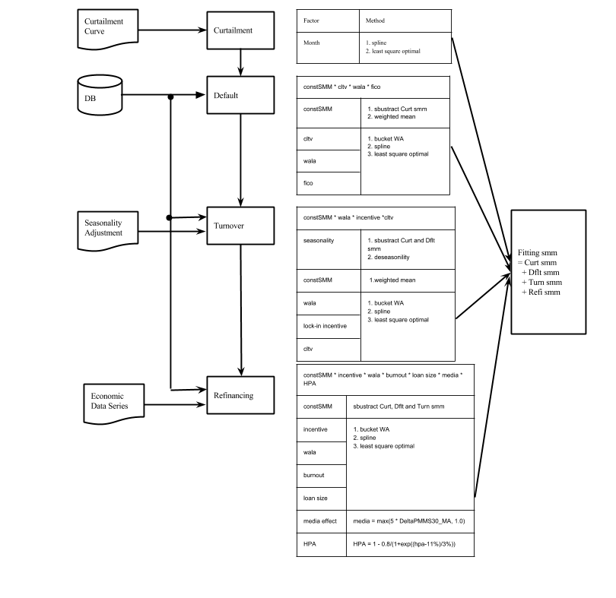

Section 2. Components Module Design

2.1 Curtailment and Full Payoff
The main idea of building a Curtailment and Full Payoff here, is build a curve using spline function and interpolation.
Model | Sub Component | Comments | Modeling Method
Curt | Month | Loan age | 1.Spline  2.Least square optimal

2.2 Default
Dflt = constSMM * cltv * wala * fico
Model | Sub Component | Comments | Modeling Method
Dflt | constSMM | Baseline Constant | 1.sbustract Curt from SMM  2.weighted mean
 | cltv | Home Equity | 1.bucket WA  2.Spline  3.least square optimal
 | wala | Seasoning
 | fico | Credit Rating

2.3 Turnover
Turn= constSMM * wala * incentive *cltv
Model | Sub Component | Comments | Modeling Method
Turn | seasonality | Seasonality | 1.sbustract Curt and Dflt from SMM  2.deseasonility
 | constSMM | Baseline Constant | 1.weighted mean
 | wala | Seasoning | 1.bucket WA  2.Spline  3.least square optimal
 | lock-in incentive | Incentive
 | cltv | Home Equity

2.3 Refinancing
Refi = constSMM * incentive * wala * burnout * loan size * media * HPA
Model | Sub Component | Comments | Modeling Method
Refi | constSMM | Baseline Constant | 1.sbustract Curt, Dflt and Turn from SMM  2.weighted mean
 | wala | Seasoning | 1.bucket WA  2.Spline  3.least square optimal
 | burnout | Incentive
 | loan size | Home Equity
 | media effect | Media Effect | media effect = max(5*DeltaPMMS30_MA,1.0)
 | HPA | Housing Market Health | HPA = 1 - 0.8/(1+exp((hpa-11%)/3%))

Section 3. Modeling Methods

3.1 Bucket and Weighted Mean
The original data from database is showed below. We can see the data distributed around several small area. The first idea is to transfer the data area into data point.
Figure 2 Raw Data
The first step is set up some bucket, and calculate the weighted mean for data drop in each bucket. We do weight mean along horizontal axis and vertical axis. And the weight for each point is its corresponding balance value. The following figures show the process of bucket and weighted mean.
Figure 3 Bucket Figure 4 Weighted Mean Figure 5 After Change Y Scale

We can see, after doing weight mean, we get one single data point in each data bucket. Those data points will be the basis for following calculation.

3.2 Spline
Now, we set up some key knots, which are the most important CLTV values that may be used as our model parameters. So naturally, we want to know the SMM value on each of the knots. Here we use cubic spline to predict those values, as the red points in figure 5.
Figure 7 Get Knots Value
Figure 6 Spline

3.3 Optimization
As mentioned in 3.2, the splined knots value is the basis to build our model. We use those values to do the spline model again. (Instead of using weighted mean values.) We get a graph as below:
Figure 8 Spine using Knots Value
The model curve (red line) pass through the weight mean points (black points). However, there is estimated error, which we want to minimize. Here we use least square method to optimize the knots value.
Error Term = ∑ (predict value on spline – weighted average value)²
After optimization, we get the blue points as optimal knots value:

Figure 9 Optimal Knots Value and Spline Curve

3.4 Modeling
So we get the spline function, as our model curve. When we get a new CLTV value, we use this spline function to predict our model SMM value corresponding to CLTV. Here we do the prediction for all the original data and show a comparison with the raw data.
Figure 10 Model Value and Raw Data

